**Data resource:** [**Mini project 1 - User churn analysis\Mini project 1 - User churn analysis\Mini project 1 - Data_đuôi_xlxs.xlsx**](Mini%20project%201%20-%20User%20churn%20analysis/Mini%20project%201%20-%20User%20churn%20analysis/Mini%20project%201%20-%20Data_đuôi_xlxs.xlsx)

**Introduction dataset**: The dataset includes a dim table with information about users of a telecommunications network provider, including fields for demographic data and data on subscriber churn.

1. **BUSINESS REQUIREMENT**

The project was established based on the managers' requests to provide an overview of churn data and churn by categories. Once the churn user group has been categorized and identified, managers want to be able to develop solutions to boost business performance in the next quarter.

1. **DATA CLEANING & TRANSFORMATION**

After empathizing with the purpose of managers, I identified two critical goals in this report that needed clarification, including evaluating overall churn statistics and classifying churn user categories.

In order to provide a valuable outcome to the report's readers, it is necessary to evaluate and clean the dataset first. After transforming the data into POWER BI and clarifying the data, I found that there are two columns, namely [Churn Category] and [Churn Reason], with a high percentage of NULL values. Therefore, to make creating the dashboard easier, I changed the NULL values in two columns to "NA" values.

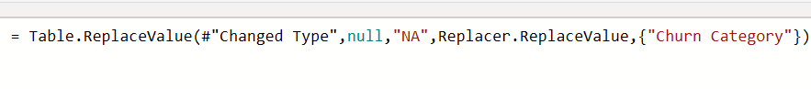

Table : Replace value - Churn Category

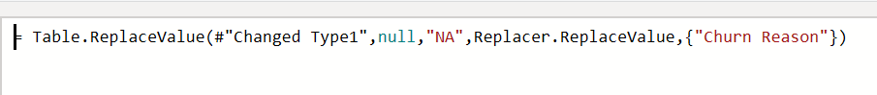

Table : Replace value - Churn Reason

1. *New column*

There are multiple columns in this dataset, so to address the paper's two main objectives, I have selected and created two more columns to provide more information during the dashboard creation process.

* **Tenure_Bin**: To reorder the period from when a customer registers an account to the present, I have created a tenure bin column with the following condition:

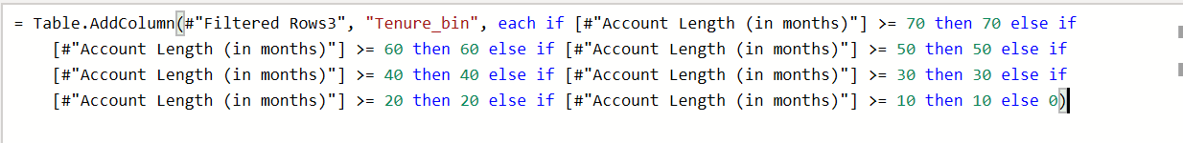

Table : New column - Tenure Bin

The tenure bin column will group consumers who opened their accounts throughout different periods, ranging from 0-70 months, into distinct categories.

* **Age condition**: To classify the age of customers, I divide age into two main categories: Over and under 30. The age condition column complies with the following conditions:

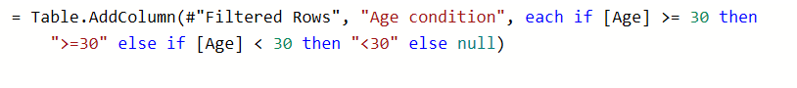

Table : New column - Age condition

1. *New measure*

Next, to collect and add more details to the dashboards, there are multiple measures were created:

To make information easier to access during the analysis, I first divided two customer files into total customers and churners.

* **Total_Count:** How many users are?

=> COUNT(CustomerID)

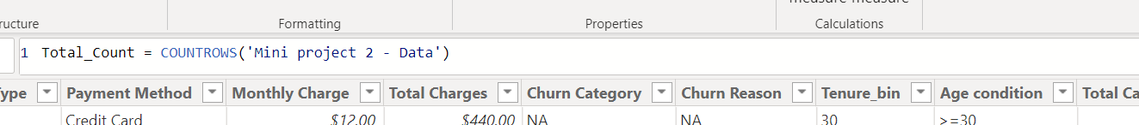

Table : Total_Count

* **Churn_Count:** How many churners are?

=> COUNT (Churn Label) with Churn Label = "Yes"

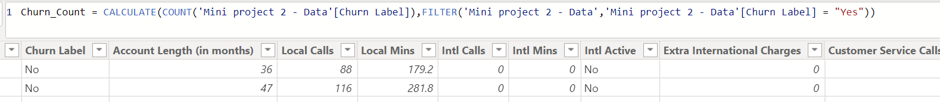

Table : Churn_Count

After listing down the key metrics, I created new measures based on total_count and churn_count as follows:

*2.1. Device Protection & Online Backup (DPOB)*

* **%DpobAll**: How many users use the DPOB package?

=> COUNT(CustomerID) with [Device Protection & Online Backup] = “Yes”

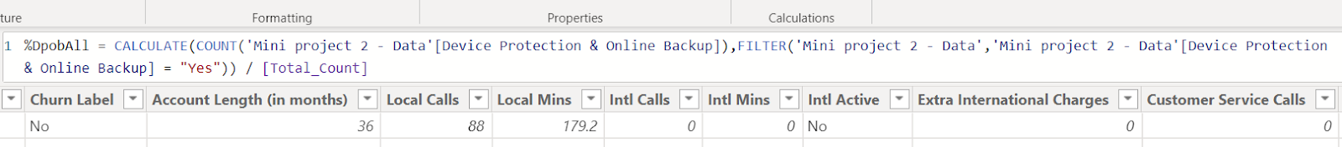

Table : %DpobAll

* **%DpobChurn:** How many churners use the DPOB package?

=> COUNT(Churn_Count) with [Device Protection & Online Backup] = "Yes"

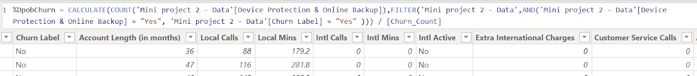

Table : %DopbChurn

*2.2. Group*

* **%GroupAll:** How many users register to use group services?

=> COUNT(CustomerID) with [Group] = "Yes"

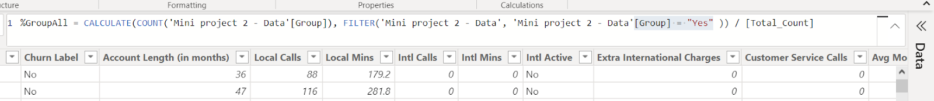

Table : %GroupAll

* **%GroupChurn:** How many churners register to use group services?

=> COUNT(Churn_Count) with [Group] = "Yes"

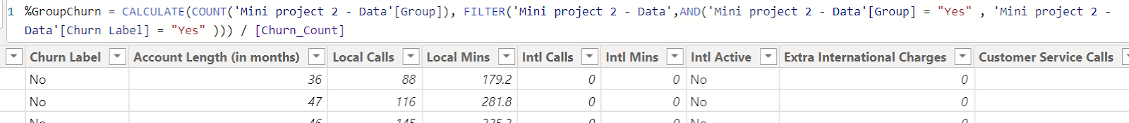

Table : %GroupChurn

*2.3. Intl Active*

* **%intl_active_call:** How many users registered for international calls?

=> COUNT(CustomerID) with [Intl Active] = "Yes"

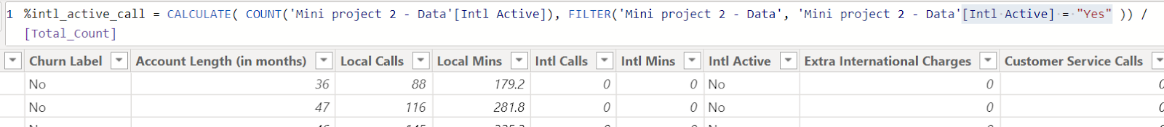

Table : %intl_active_call

* **%intl_active_call_churn:** How many churners registered for international calls?

=> COUNT(Churn_Count) with [Intl Active] = "Yes"

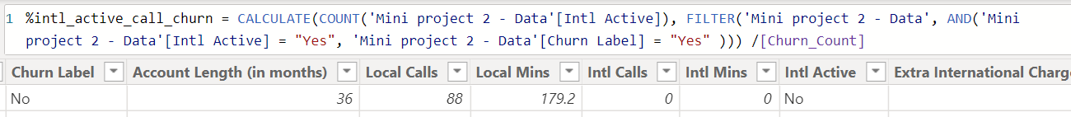

Table : %intl_active_call_churn

*2.4. Age condition*

* **%Over30All:** How many users are over 30 years old?

=> COUNT(CustomerID) with [Age condition] = ">=30

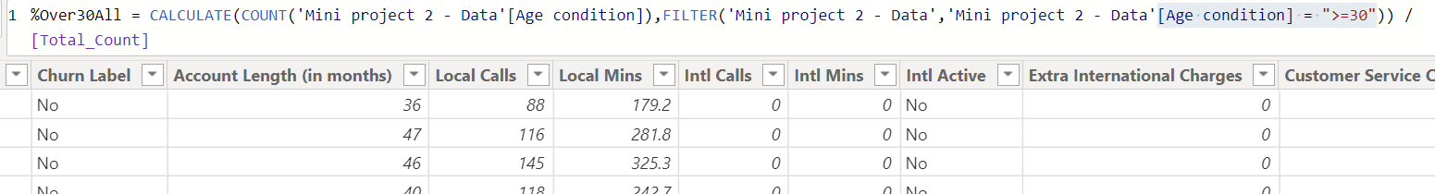

Table : %Over30All

* **%Under30All:** How many users are under 30 years old?

=> COUNT(CustomerID) with [Age condition] = "<30"

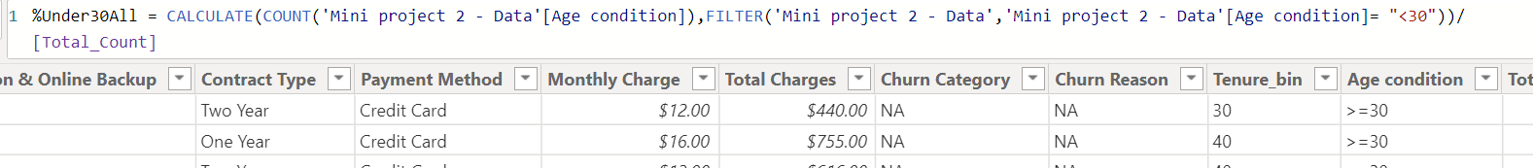

Table : %Under30All

*2.5. Unlimited Data Plan (UDP)*

* **%udp_all:** How many users use Unlimited Data Plan?

=> COUNT(CustomerID) with [Unlimited Data Plan] = "Yes"

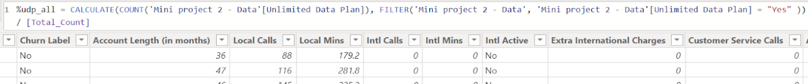

Table : %udp_all

* **%udp_churn:** How many churners use Unlimited Data Plan?

=> COUNT(Churn_Count) with [Unlimited Data Plan] = "Yes"

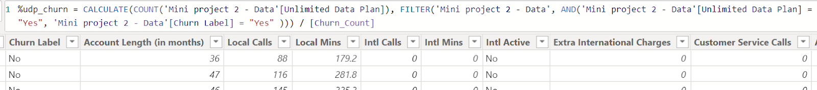

Table : %udp_churn

*2.6. Monthly Charge*

* **avg_monthly_charge_all:** What is the average user's charge per month?

=> CALCULATE (AVERAGE (Monthly Charge))

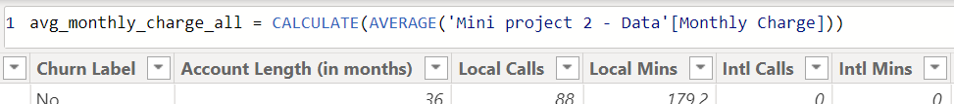

Table : avg_monthly_charge_all

* **avg_monthly_charge_churn**: What is the average churner's charge per month?

=> CALCULATE (AVERAGE (Monthly Charge)) with [Churn Label] = "Yes"

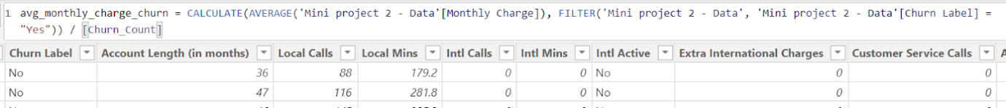

Table :avg_monthly_charge_churn

*2.7. Total Charges*

* **avg_total_charge_all**: What is the average user's charge per year?

=> CALCULATE (AVERAGE (Total Charges))

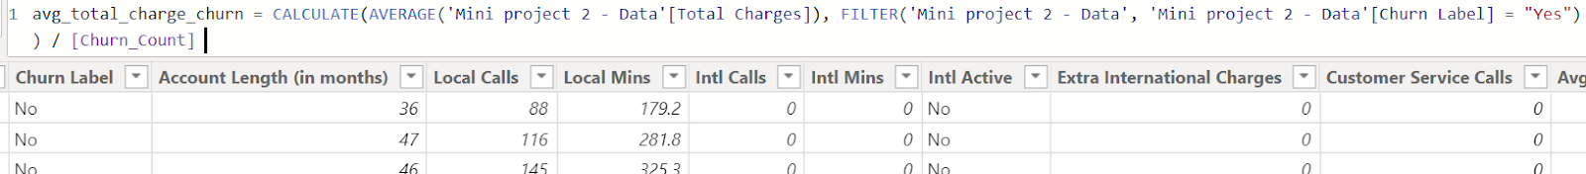

Table : avg_total_charge_all

* **avg_total_charge_churn**: What is the average churner's charge per year?

=> CALCULATE (AVERAGE (Total Charges)) with [Churn Label] = "Yes"

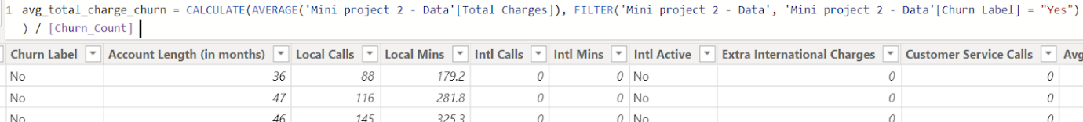

Table : avg_total_charge_churn

1. **DATA ANALYSIS**

In order to facilitate the analytical process, I have built a dashboard to aggregate information about customers and churn users. The dashboard has three main parts: Customer overview, Customer detail, and Churn reason.

1. ***Customer overview***

*1.1. Demographic*

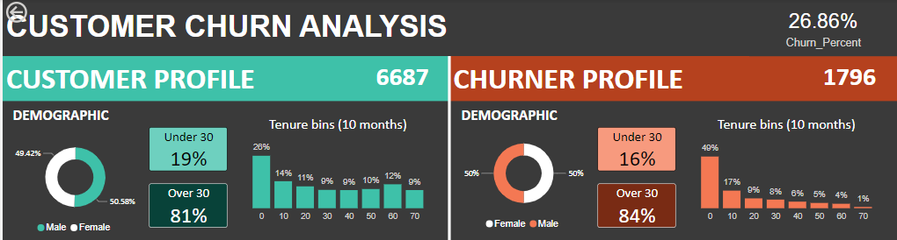

Table : Demographic

A total of 6678 clients have so far signed up with the business; of these, 1796 have churned, making approximately 27% of the total.

According to Statista, the company's percentage of customer churn is 6% higher than the industry average (21%) compared to the customer churn rate in the United States in 2020. This is the company's wake-up call to address the churn problem and find a solution.

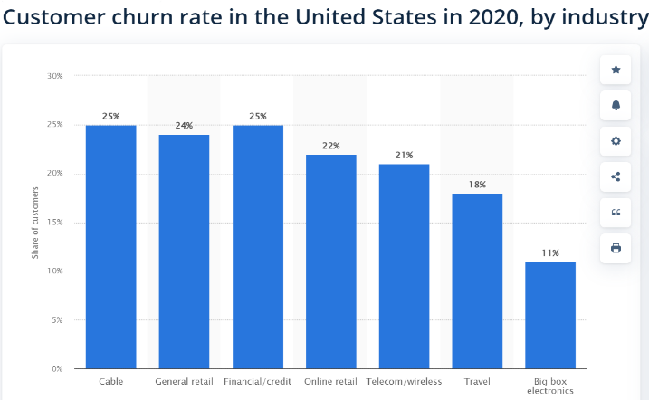

Figure : Customer churn rate in US

Overall, users showed no gender differences, roughly 50% being male and female. Less than 20% of network users are under 30, and the majority (more than 80%) are above 30.

Regarding the tenure bin, clients who opened accounts for less than ten months accounted for 26% of total customers and 49% of total churn. Additionally, less than 20% of clients opened accounts in the 10-70month timeframe.

*1.2. Service*

The display shows that the Unlimited Data Plan is the most popular and frequently utilized service, with over 67% of all customers and 80% of all churn. Second, international call registration services comprise the second-largest share, with active international customers accounting for 48.45% of all customers and 49.11% of all churn, respectively. Customers also utilize other service combos like Device Protection & Online Backup and Group, with a rate of less than 35% overall.

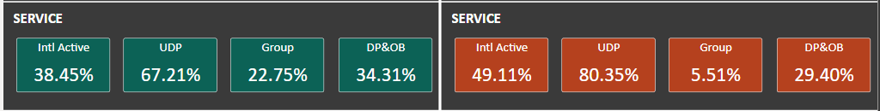

Table : Service

*1.3. Contract*

In terms of the contract, the company offers three main options, including month-to-month, one-year, and two-year.

With 51.01% of all customers and 87.92% of all churn, month-to-month is the most favored option among users. Next, the proportion of users on a one-year plan represents around 27% of all customers and more than 9% of all churn. In addition, churner does not employ a two-year contract, and just 22% of consumers use a two-year plan.

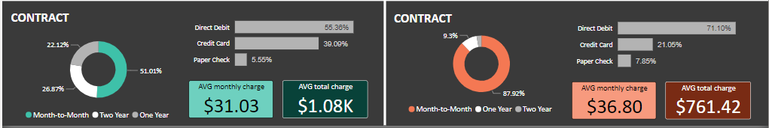

Table : Contract

The most popular payment methods are direct debit and credit card, with a usage rate of 55.36% and 39.09% in total customers, respectively. Paper check is an out-of-date option and is no longer used by customers, accounting for just under 6%. In addition, the average customer spends $31.03 monthly to pay for service fees, with an average total charge of $1.08k.

Below is the dashboard overview:

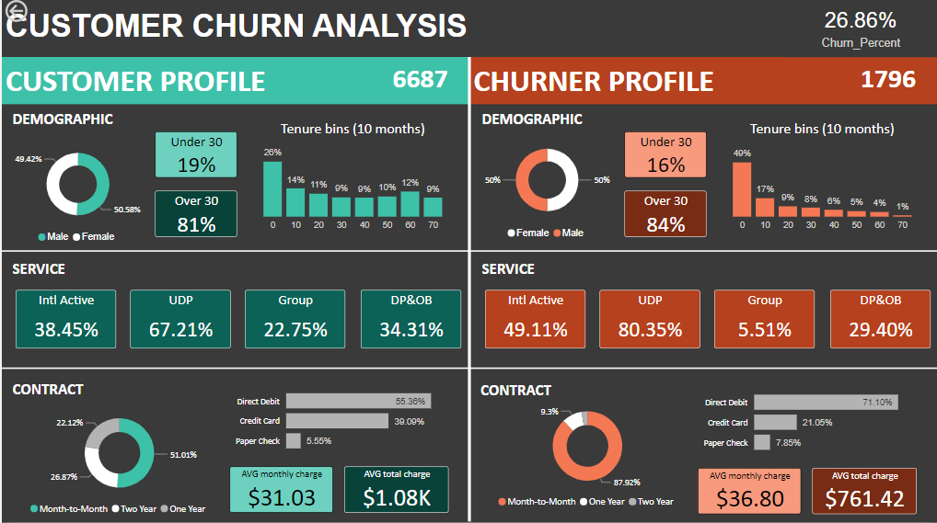

Table : Overview customer churn

1. ***Customer detail***

In the customer detail section, I have prepared a dashboard that specifies each client's personal, contract, service, and churn reasons to give readers sufficient information in case they are interested in the specifics of each customer's data.

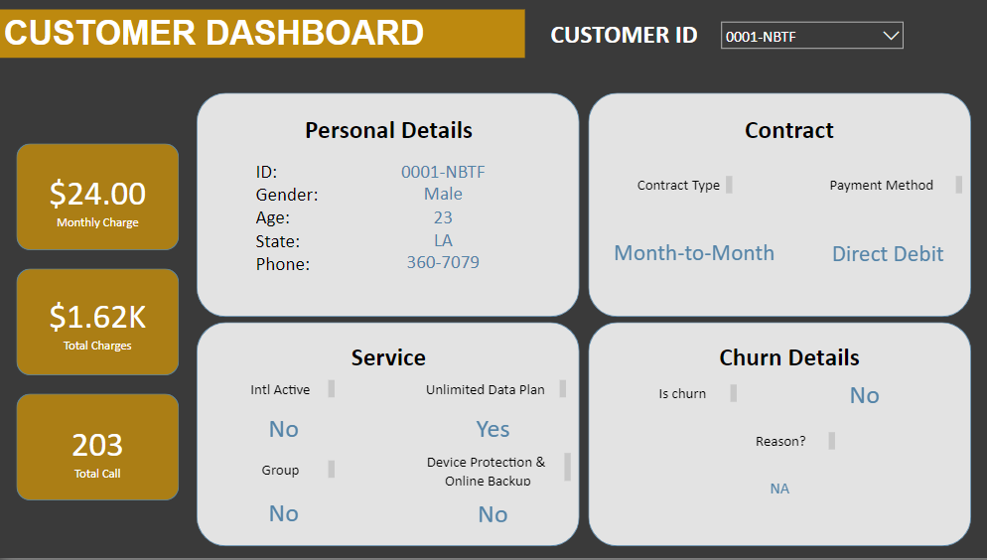

Table : Customer detail

1. ***Churn reason***

Regarding churn reasons, it is clear that competition (which accounts for 45%) is the main factor driving up churn rates. This is because competitors have successfully offered deals and high-quality devices. Next, attitude is the second reason customers look for better alternatives, primarily due to dissatisfaction with the attitude of the support staff. In addition, other factors lead to increased churn rates, such as dissatisfaction and price, which are 16.17% and 11.31%, respectively.

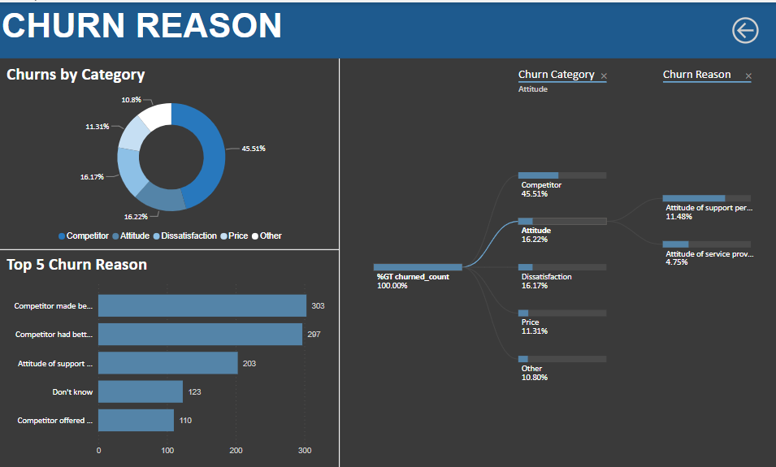

Table : Churn reason

1. ***Recommendation***

After doing an overall analysis of customer and churn reasons, it can be concluded that regardless of the type of reasons (Competitor, Attitude, Dissatisfaction, Price), they all lead to the following three main issues:

* Providing products
* Customer services
* Price

Therefore, I'll concentrate on analyzing these three primary causes.

*4.1. The product*

Clearly, the dataset needs to be more sufficient for conducting a thorough product analysis. Therefore, before making recommendations about product types, it is necessary to dig deep and clarify some issues as follows:

First, it is vital to list all of the current products that the business offers:

* What products does the company offer?

The next step is to gather data and conduct a survey for additional research to determine the causes of customers' dissatisfaction with the product.

* What is the dissatisfaction with the products?

After having a deep understanding of the product and the factors contributing to customer dissatisfaction, the R&D Department are able to concentrate on product research and development to improve the customer experience.

* How to improve the current product?

*4.2. Customer service*

Regarding customer service, attitude is considered the third main factor in a company's 27% churn rate.

Therefore, more details are required to assess and understand how the customer service team operates.

* How is the customer services team doing?

After evaluating the team's performance, it is vital to rearrange the staff and find ways to improve quality through new rules or policies to motivate employees to work better.

* Can they improve their quality with new rules or incentives?

*4.3. Price*

Price is crucial for the customer's decision whether to leave or stay with the business. According to the dashboard, the price contributes roughly 12% of the rise in the churn rate. Therefore, the company needs to do more research on competitors to gain a deep understanding of its competitive products.

After that, the company can re-evaluate the pricing model and consider adjusting the "customized price" through promotional activities for each user age to attract customers.

Overall, it can be concluded that "Competitors" is still arguably the most significant driver for user turnover (45.5%). Therefore, it is necessary to combine the development of the company's products & services and perform a thorough competitor analysis to come up with new and relevant ideas to increase the competition rate in the market.